VM Registration Script

Purpose:

* This documentation provides information about the script used for VM registration for nagios.
* It also include how run the script on redhat 7.
* Documentation also contain how to check if script run successfully.

Contents

**Review and Version Information**: 3

**Introduction:** 4

**Script1:-Installing NRPE Plugin on Linux (REHL)** 4

Step1:- Enabling the Repos 4

Step2: Installing the packages 4

Setp3: Creating User for Installation 5

Step4:-Downloading the Installing the NRPE Plugin 5

Step5:-Setting the Permissions and installing the xinetd. 6

Step6:-Downloading the NRPE PLUGIN Package and Installing the NRPE. 7

Step7:-Installing the Xinetd and Configuring Nrpe Plugin 7

Step8:-Enabling the Xinetd service and Adding the Port No 5666 in firewall tables. 8

Step9:-Writing information about the client machine into the file and transferring the file to Nagios Server. 8

**Script2:-On Nagios Server** 9

Step1:-Appending the Client information Files into one file 9

Step2:-Adding information about the client in the nagios Server Configuration files. 10

Step3:-Adding the Client IP Address and Hostname in hosts file on Nagios Server. 11

Step4:-Taking the Backup of the file 11

Step5:-Restarting the Nagios Server and Checking 11

# **Introduction:**

This Documentation contain information about the VM Registration Script and how to run the script. It contains information about every configuration need to be done. There are two scripts created for this script1 runs on the machine which needs to be monitored. And script2 run on the nagios server which put the information about the machine on nagios server configuration files. Following is the information about the script.

# **Script1:-Installing NRPE Plugin on Linux (REHL)**

## Step1:- Enabling the Repos

* In this section of the script it will enable the repo so that it can download the required packages.
* All the repo are under/etc/yum.repos.d/

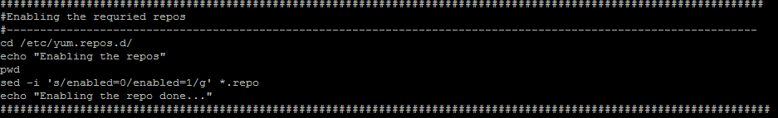

## Step2: Installing the packages

* In the below Section the script will download the required package for nrpe installation.



## Setp3: Creating User for Installation

* In this section we will create a user which will be used to set the permissions and used throughout the installation.

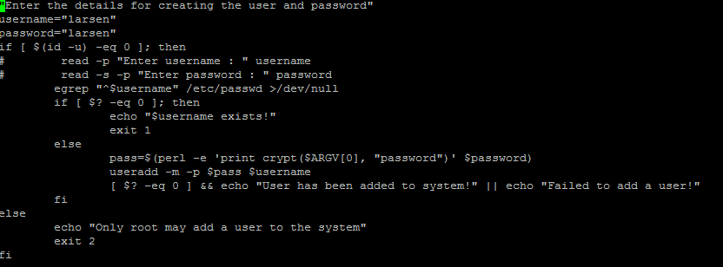

## Step4:-Downloading the Installing the NRPE Plugin

* In this sections we have created a directory where all the packages are download.
* Once the packages are download we need to untar it and the script will install the packages.

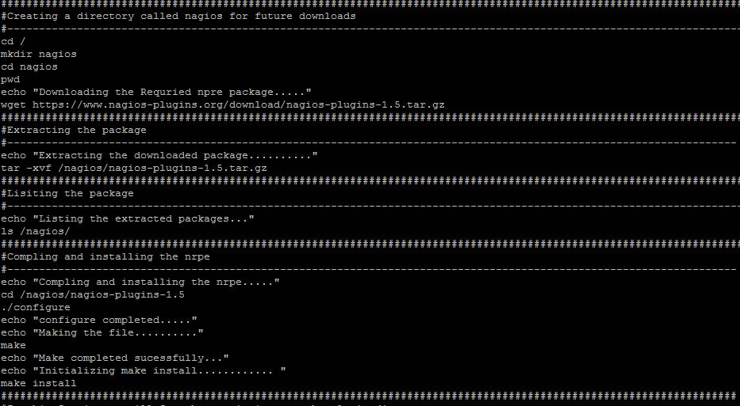

## Step5:-Setting the Permissions and installing the xinetd.

* In this section it will set the permissions on the plugin folder and change the owner to nagios
* It also install the Xinetd package also.

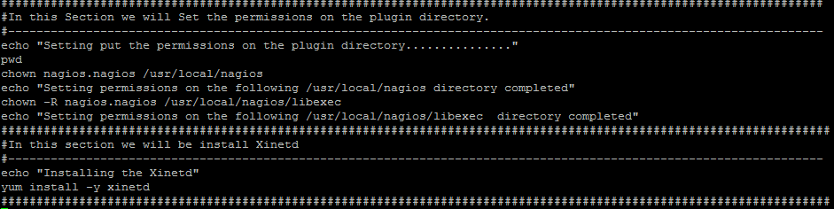

## Step6:-Downloading the NRPE PLUGIN Package and Installing the NRPE.

* In this Section the script will download the NRPE Plugin and untar the package and install the nrpe.

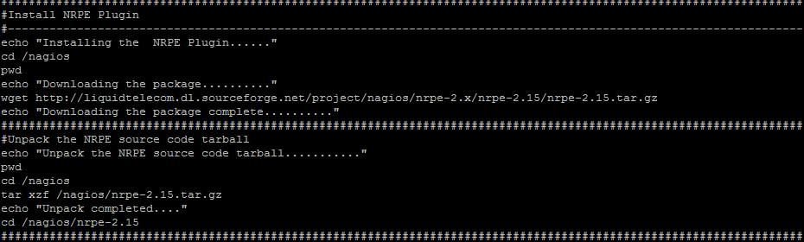

* In the Next section it will compile the package and install the nrpe plugin.

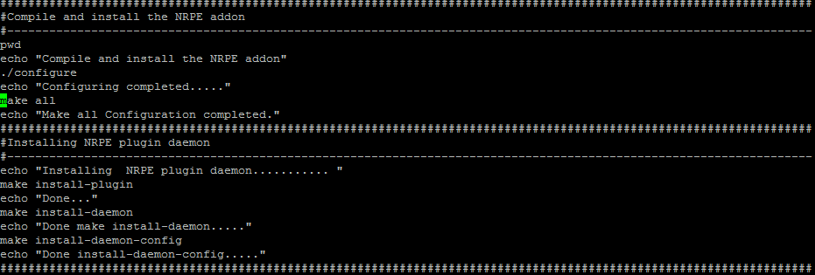

## Step7:-Installing the Xinetd and Configuring Nrpe Plugin

* In this section we need to install Xinetd so that we can run the nrpe plugin as a daemon process.
* We also need to enter the IP address of the nagios server into the following file /etc/Xinetd.d/nrpe
* Script will also add the NRPE Service Details in the /etc/services file.

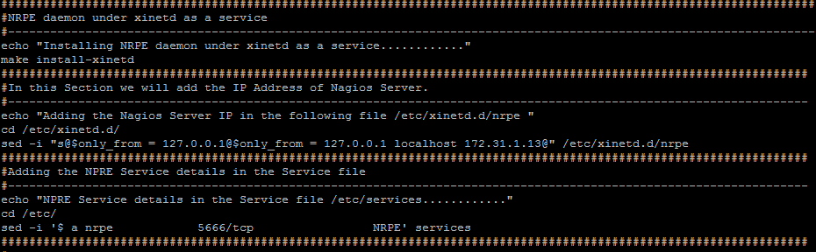

## Step8:-Enabling the Xinetd service and Adding the Port No 5666 in firewall tables.

* In this section the script will restart the Xinetd service and also add the port no 5666 in the firewall tables so that it can accept request on the port 5666.

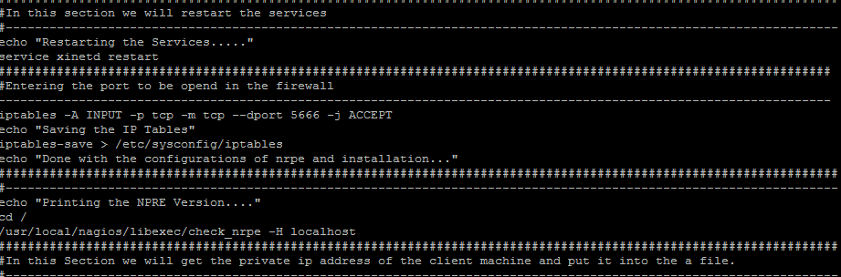

## Step9:-Writing information about the client machine into the file and transferring the file to Nagios Server.

* In this Section of the Script it will collect the information about the Client machine i.e. is hostname and IP Address of the machine. And Put it into a file.
* It will connect to the nagios server and copy the file on the nagios server at a specified location.

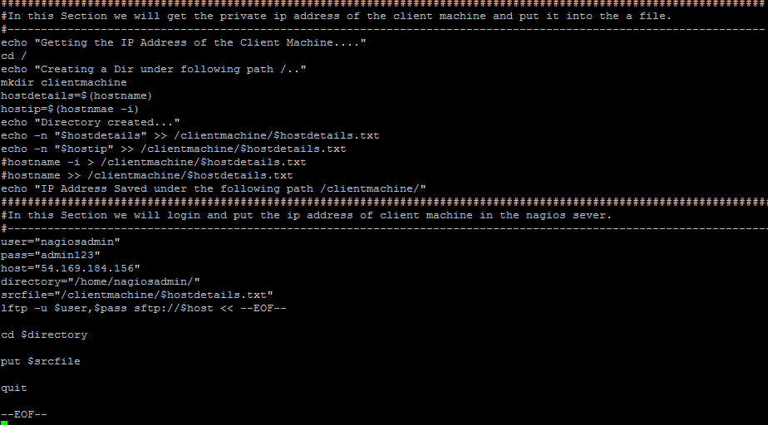

# **Script2:-On Nagios Server**

## Step1:-Appending the Client information Files into one file

* In the below section the script is appending all the client information into one file.
* All the client information file which come from client machine is saved under following directory
* /home/nagiosadmin/
* Script append all the information into one file.

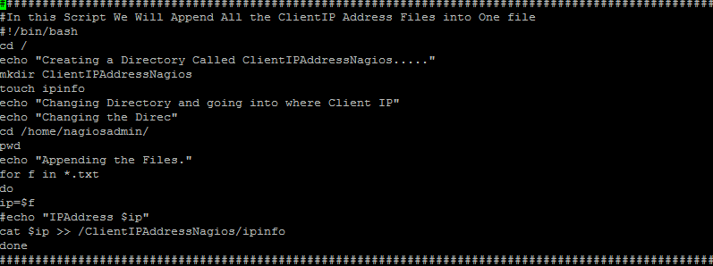

## Step2:-Adding information about the client in the nagios Server Configuration files.

* In this section of the script the script will put the IP Address and Hostname of the Client Machine into the Nagios Configuration i.e. under following path.
* /opt/nagios/etc/hosts.cfg

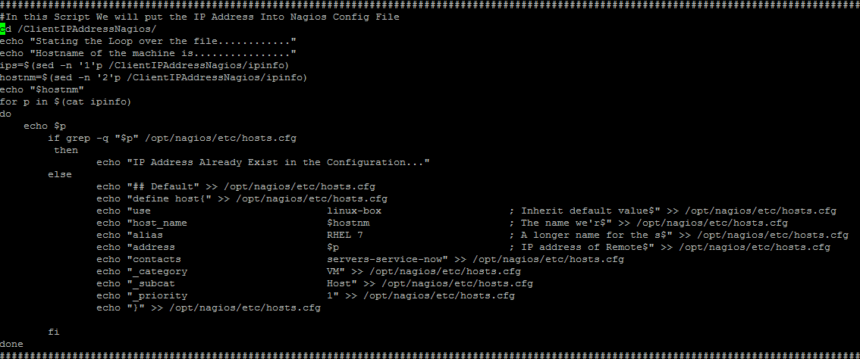

* In this Section the script will put the information about the client into the services.cfg file which is located under the following path.
* /opt/nagios/etc/services.cfg



## Step3:-Adding the Client IP Address and Hostname in hosts file on Nagios Server.

* In this Section we will add the information about the client machine i.e. IP address and the Hostname in the following directory.
* /etc/hosts

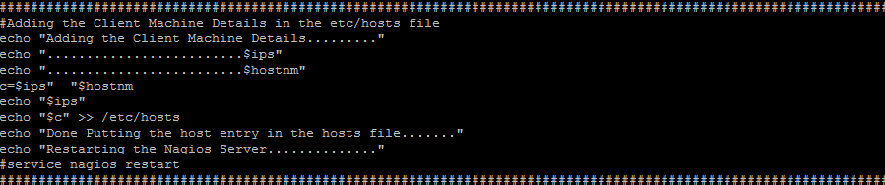

## Step4:-Taking the Backup of the file

* In this Last Section of the script backup of the file is kept.

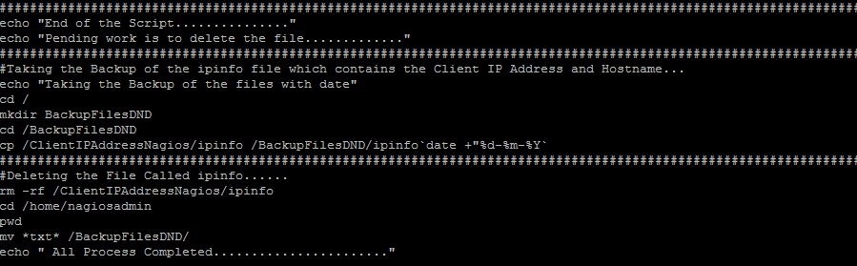

## Step5:-Restarting the Nagios Server and Checking

* Enter the following command to restart the nagios server
* service nagios restart
* Login into the nagios WebUI and check if the client machine is registered.